Laurice Sattouf

Choi Tim Anthony Young

Dimitri Garcia

ECE4304- Lab 7

4/19/2021

Professor M. Aly

**Building a System With UART**

**Purpose:**

* Design a system that take the data from the computer into the board using the UART communication protocol(Async). The data will be distributed into two different ports, FIFO-A and FIFO-B, and each output of these ports will be connected to the Barrel shifter. The output of the barrel shifters will be 2 inputs to the ALU to make all the operations needed, Arithmetic for now. The output will be 16 bit displayed on 7-segment display.
* FIFO-A and FIFO-B will be controlled by empty and full leds.
* Switches will be as follow:
  + 3bits for the Barrel Shifter-A
  + 3bits for the Barrel Shifter-B.
  + 2 bits for the ALU to choose the operations.

The schematic of the design is the following:

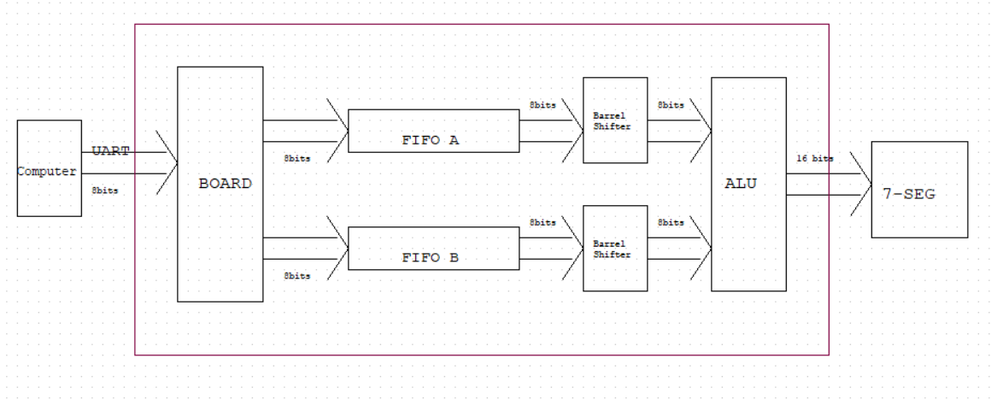

**Schematic:**

Wrapping all the component created, we end up having the following design:

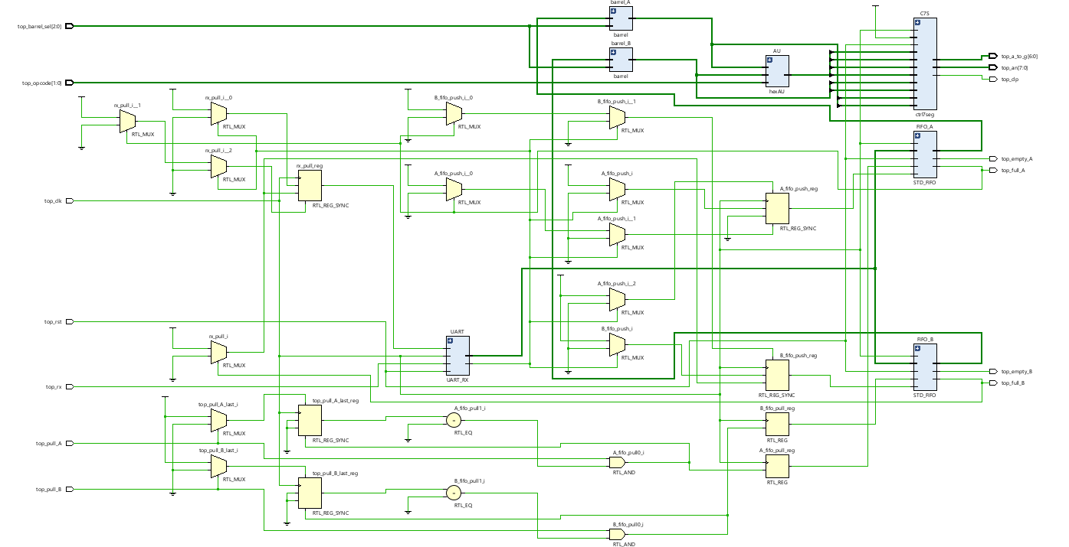

**Power and Resources Used:**



247 lookup tables and 0.123 total power used to implement this design using Vivado.

**Work Contribution:**

* We had a meeting to brainstorm and explain the main idea of the lab, and we created the schematic so that everyone would work individually to achieve the most optimized design.
* We had a zoom meeting to choose the design with less power consuming, then we were able to demo our implemented design and cover all the corner cases.
* Documentation and reports were evenly distributed, and it covered all the steps of our successfully implemented design.